**Heuristic**

**Evaluation**

**Report**



This heuristic evaluation was conducted based on The House of Rare website <https://thehouseofrare.com/> and mobile app.

(Accessed 14th September, 2022)

Evaluators: Kishlay Kumar, Pratyay Prakhar, and Vivek Kumar

Course: Introduction to Human Computer Interaction

Instructor: Sudheendra Hangal

Date: 16th September, 2022

# Table of Contents

Executive Summary

About The House of Rare

Methodology

Findings and Actionable Recommendations

#1: Visibility of System Status

Positive

Negative

#2: Match between system and real world

Positive

Negative

#3: User control and freedom

Positive

Negative

#4: Consistency and Standards

Positive

Negative

#5: Error Prevention

Positive

Negative

#6: Recognition rather than Recall

Positive

Negative

#7: Flexibility and efficiency of use

Positive

Negative

#8: Aesthetic and minimalistic design

Positive

Negative

#9: Help users recognize, diagnose, and recognize from errors

Positive

Negative

#10: Help and documentation

Positive

Negative

Conclusion

# Executive Summary

The heuristic evaluation was conducted for the partial fulfilment of the requirements of the course, ‘Human Computer Interaction’. A Heuristic Evaluation is a usability inspection method that helps identify problems in the user-interface design without involving the actual users. The evaluation is conducted by experts who judge the compliance of the interface with the recognized standards called ‘usability principles’ developed by Jakob Nielsen in 1995.

The evaluation was conducted by 3 evaluators on The House of Rare website and mobile application. This report contains a concise introduction to the application followed by the methodology used for creating this report, and details the findings of the evaluation carried out against the usability principles to highlight the positive and negative aspects of the design of the interface.

As a part of the evaluation, the problems identified were mapped to the heuristics violated. The details of the issues identified during the user journey and the recommendations to improve the user experience are presented in this report.

The majority of the usability issues identified revolve around the lack of consistency of the interfaces, their designs, and the violation of various validation constraints which provide ample opportunities for the users to make mistakes. The lack of integration of the website for the different categories also hampers the overall user experience.

This evaluation intends to provide insights into how the overall user experience can be improved by incorporating changes in the design by adhering to the usability standards followed across industries.

# About The House of Rare

The House of Rare is a premium & luxury brand that offers designer wear for men and women who love exclusive, luxury, and international designs. The main pillars of the company lie in:

* Simplicity
* Quality
* Craftmanship

The goal of the brand is to provide variety and styles while being all-inclusive and are currently working on providing all plus-size clothing to cater to the needs of everyone.

They design, manufacture and retail men's and women’s apparel under the Brand Names: Rare Rabbit and Rareism. Started in the year 2005, they now have 1 production plant and 51 stores.

Their ultimate ambition is to celebrate the uniqueness of every wearer by inventing fashion solutions for those who are raring to move ahead of the curve.

# Methodology

The user flows for the evaluation include the onboarding of the customer on the application, the process to purchase a product, and the process to return a product if needed.

The evaluation was carried out independently by the evaluators who jotted down all the violations of heuristics by strictly following the compliance standards of Nielsen’s usability principles. The user journey was critically analysed to understand both the positives and negatives associated with the interface of the applications and the emphasis was placed on giving constructive feedback and ideas to improve the overall product.

The evaluation was carried out on both the website and mobile application. The website evaluation was done using Edge, Chrome, and Safari browsers. The mobile app evaluation involved both Android as well as iOS apps.

Post the independent evaluation, the evaluators discussed their findings and gave insights into their judgement of the overall evaluation in terms of usability. These findings were finally combined into this report. The relevant screenshots were added wherever necessary to bring more clarity to the subject being discussed.



# Findings and Actionable Recommendations

## #1: Visibility of System Status

### Positive:

* In case of internet connectivity issues, the app displays an appropriate message regarding network failure to keep the user informed.
* The colour text displayed on hover is helpful for colour-blind users.

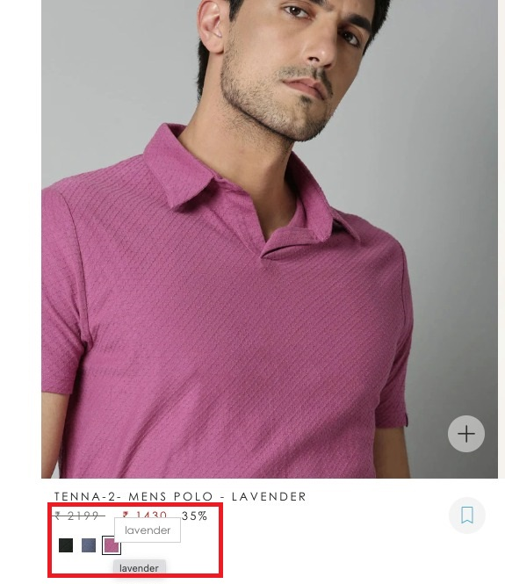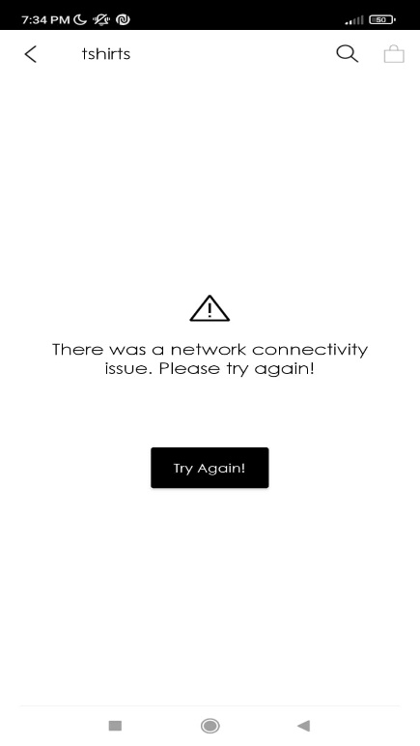

### Negative:

* A hyperlink enables the user to be notified via email if a particular size is not available. However, on hover, this link appears to be like any other selectable text on a webpage resulting in incorrect feedback to the user.



**Recommendation:** A standard hand pointer and underlined text on hover is a simple and clean solution to provide appropriate feedback.

* When accessing the ‘Size Chart’ the mobile app shows a blank screen for a few seconds before the chart is loaded.



**Recommendation:** A basic circular progress bar informs the user that the chart is loading and prevents any unwanted actions on his part.

## #2: Match between System and real world

### Positive:

* The mobile app does a good job of making things intuitive and easily discoverable for the users using real-world icons like shopping bag for carts.

### Negative:

* The ‘Store Locator’ section of the app displays a jargonic error message when there is a connectivity issue.

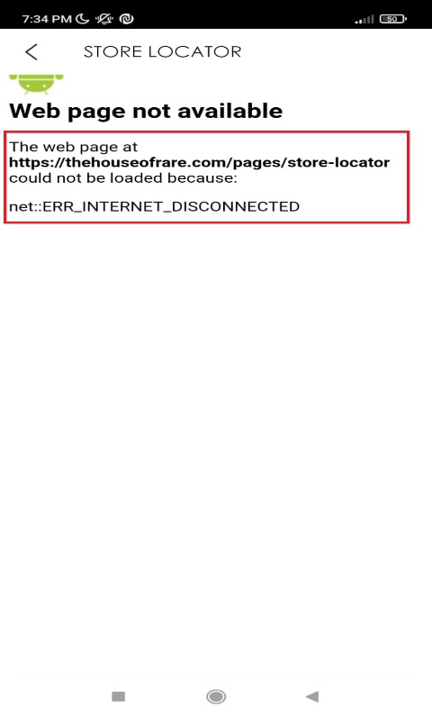

**Recommendation:** Exception handling could be improved to display a more user-understandable error message like the one highlighted in Heuristic 1.

* The use of the ‘Rare Rabbit’ icon to go to the Home Screen in the mobile app is ambiguous as it may be confused for something else (like an About Us page).

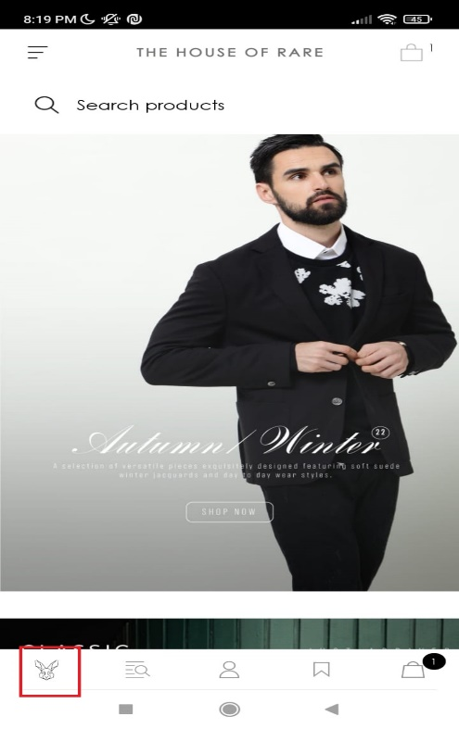

**Recommendation:** A simple and well-understood icon like the ‘Home Icon’ aligns well with the mental model of the user.

## #3:User control and freedom

### Positive:

* --Need to Identify--

### Negative**:**

* Separate web pages for men’s and women’s clothing deny the user the freedom to shop for multiple people together.



**Recommendation:** This may be a business constraint but if not, then integrating the two websites allows greater freedom and a better user experience.

* Once added to the cart, the website does not give the option to change the size and colour of the product. The user must remove the product from the cart, select his new preference and add it again.

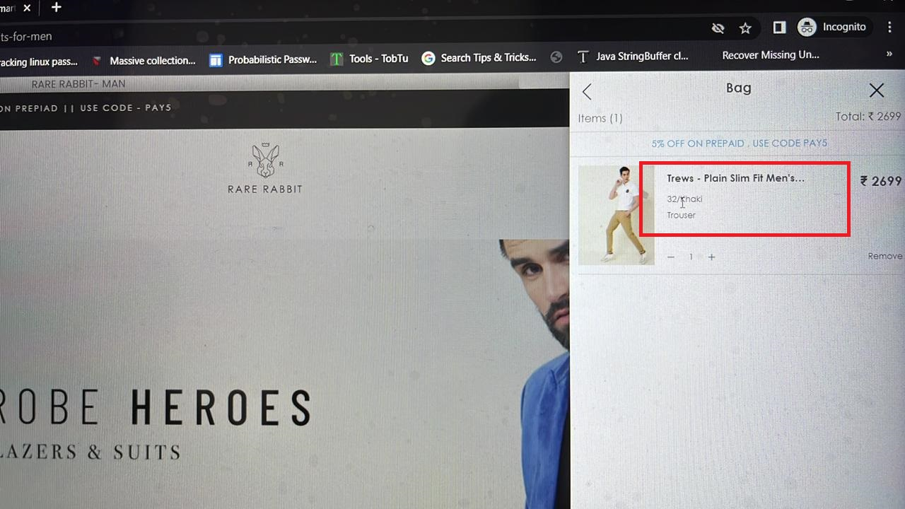

**Recommendation:** The option to edit the size and colour of the apparel can be enabled in the cart, as seen on other clothing brand websites.

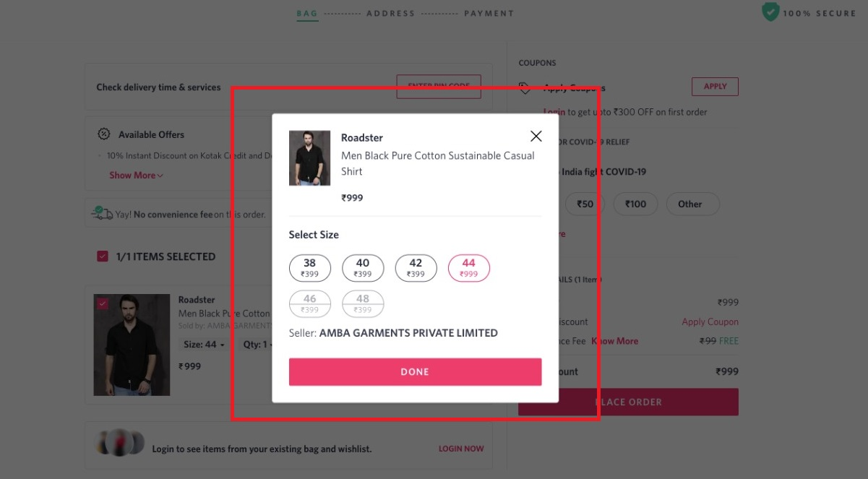

## **#**4: Consistency and Standards

### Positive:

* 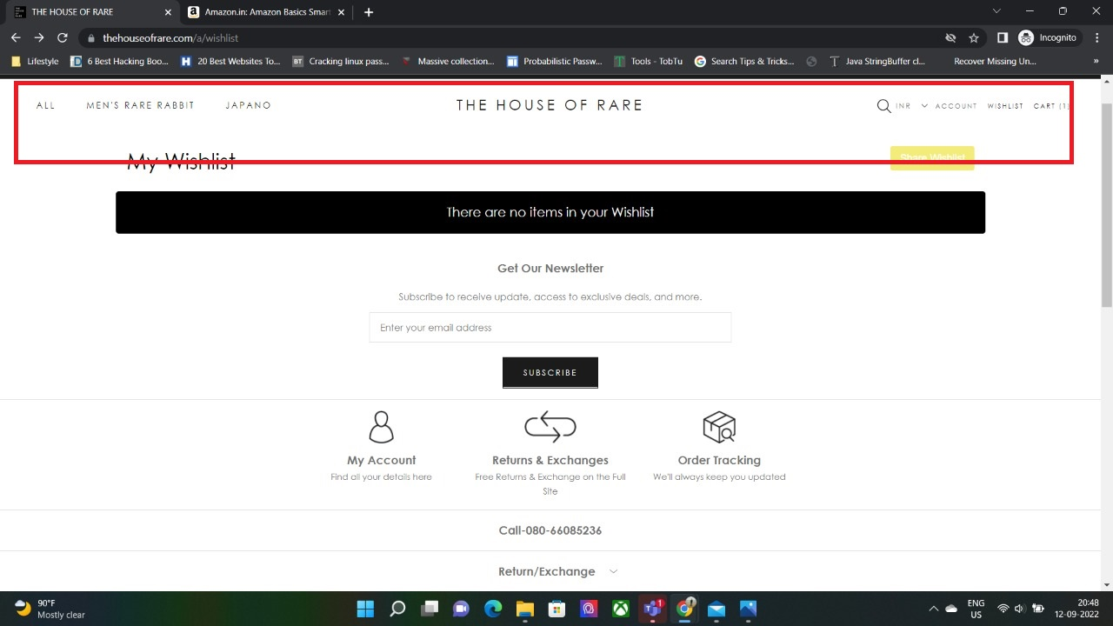The website header is consistent across all the pages and allows the user to navigate easily.
* The layout used for sorting and filtering apparel conforms to the standards established for e-Commerce platforms.

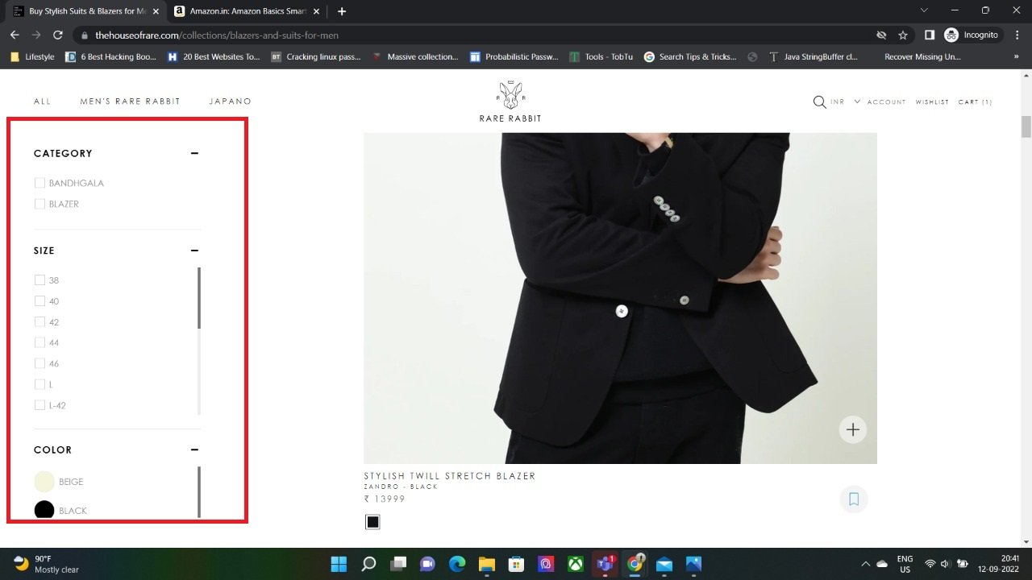

### Negative:

* The mobile app displays the ‘Cart Icon’ at multiple places on the same screen which is inconsistent with the layout and unnecessary.

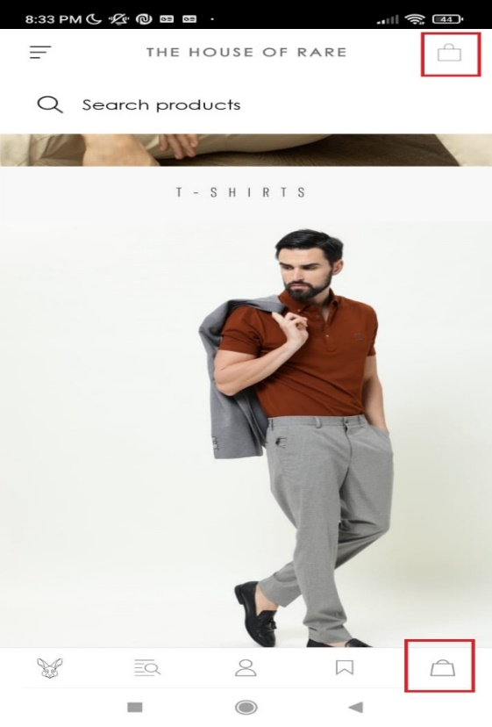

**Recommendation:** Since the bottom navigation bar remains constant across all screens, the cart icon can be displayed there and removed from the title bar.

* When sorting the products in the mobile app, a Toast is displayed which is inconsistent and cryptic in its language.

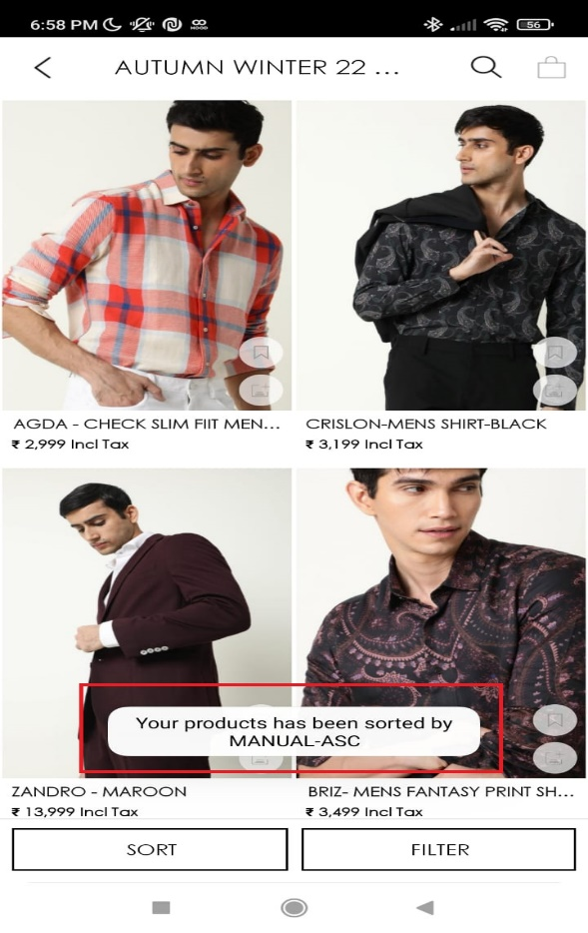

**Recommendation:** The toast itself doesn’t seem necessary since the sorting menu already mentions the order of sorting. However, if it must be displayed, then the language must be complete.

## #5: Error prevention

### Positive:

* Numeric constraints are enabled when a user adds his contact number which prevents spurious values.

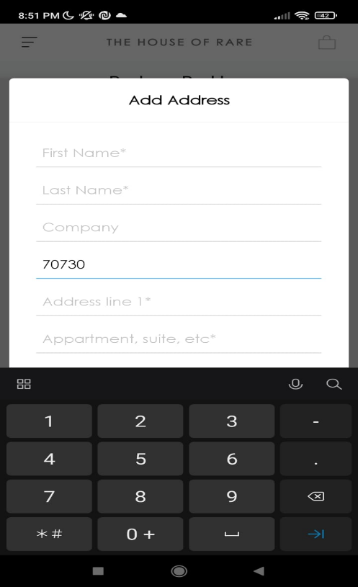

Negative:

* View password option does not exist.

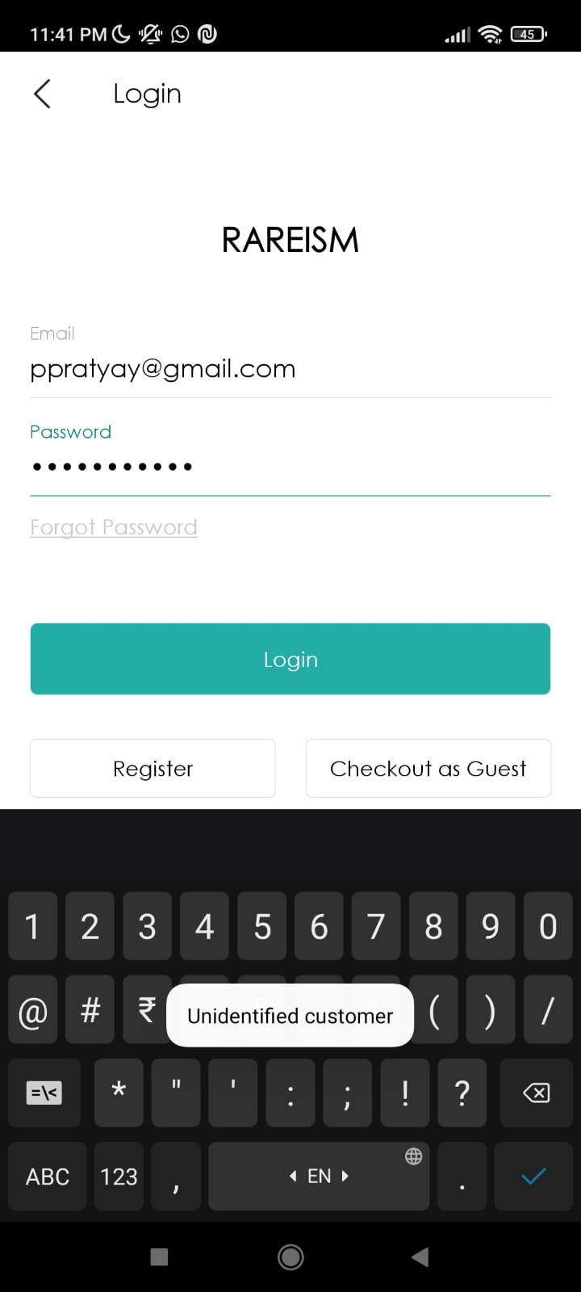

**Recommendation:** The option to view password helps users rectify incorrectly entered passwords.

* There is no constraint on the number of units a user can purchase.

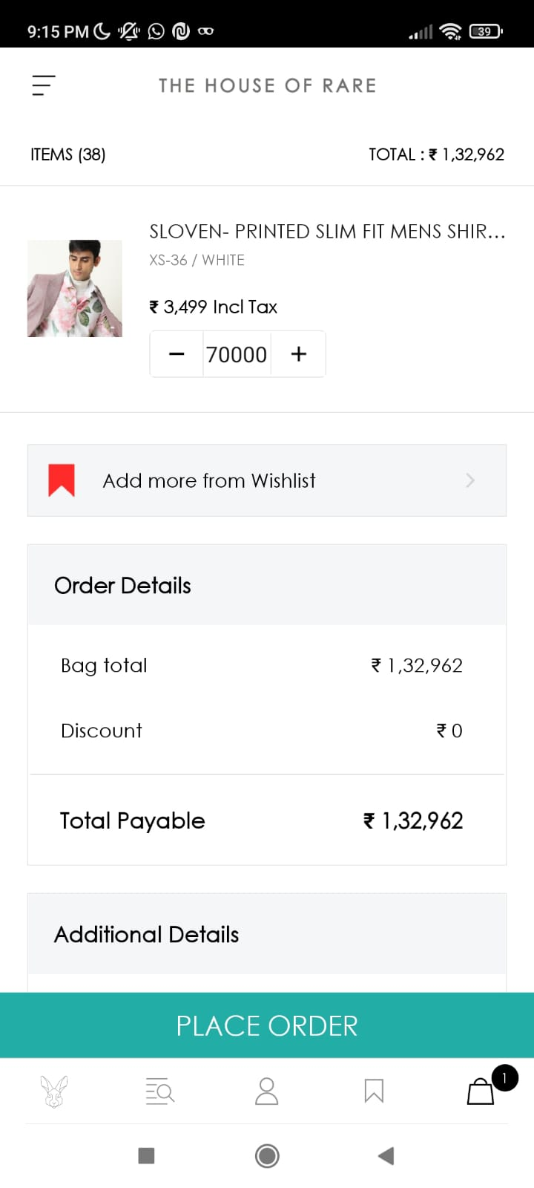

**Recommendation:** Even though the price on the next page is self-explanatory, a popup window asking the user to confirm his choice in case the number of units exceeds a threshold is recommended.

* There is no validation of the sender details like email, name, and the pin code while adding/updating the address.

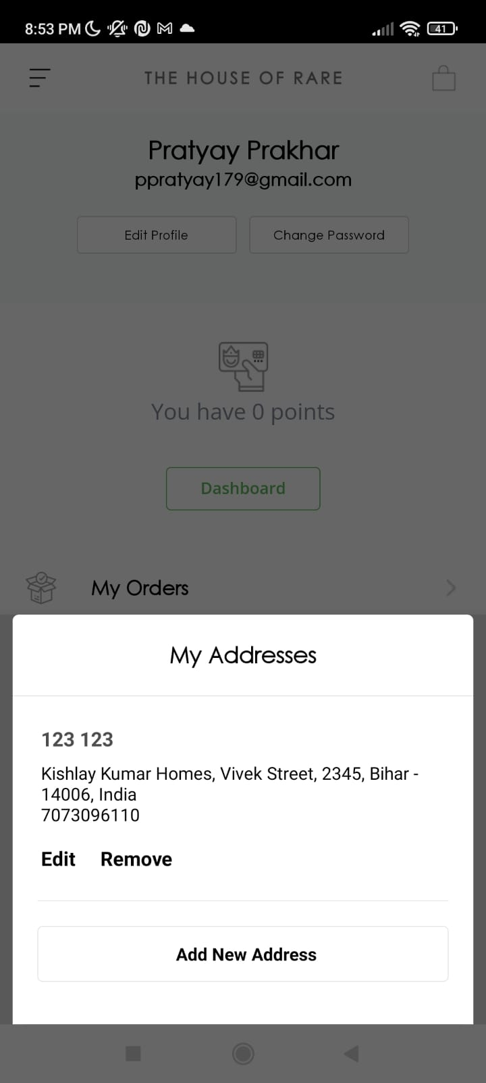

## #6: Recognition rather than recall

Positive:

* Login options using email and other social media accounts saves the unnecessary hassle to enter all the user details.

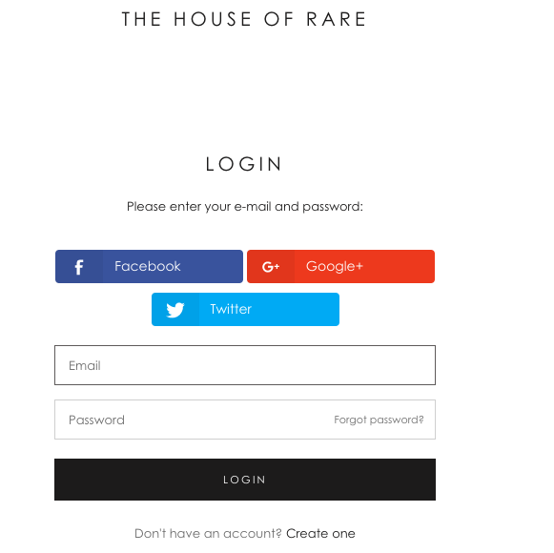

### Negative:

* There is no visible next option after adding an item to cart.

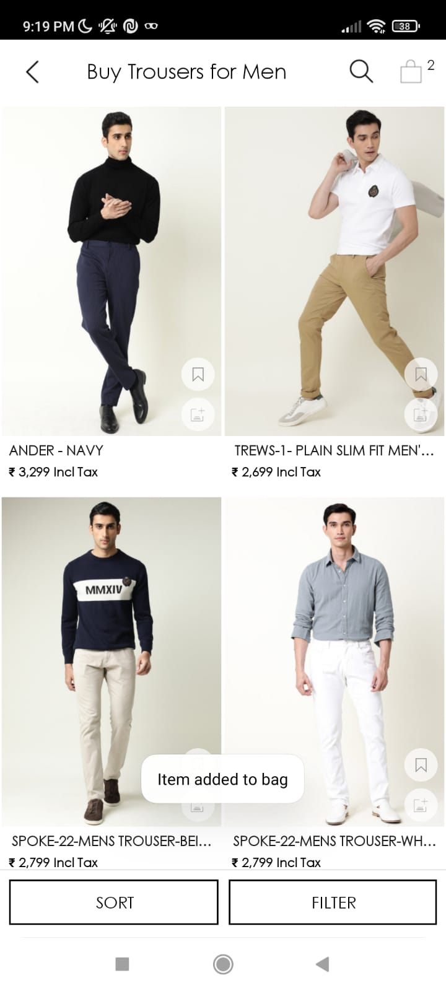

**Recommendation:** The next logical step after a user adds an item to his bag would be the ‘Go To Cart’ option for smoother navigation.

## #7: Flexibility and efficiency of use

### Positive: NA

### Negative:

### The FAQ section is erroneously placed under the Returns and Exchange menu on the website and the mobile app which is extremely inefficient to navigate to.

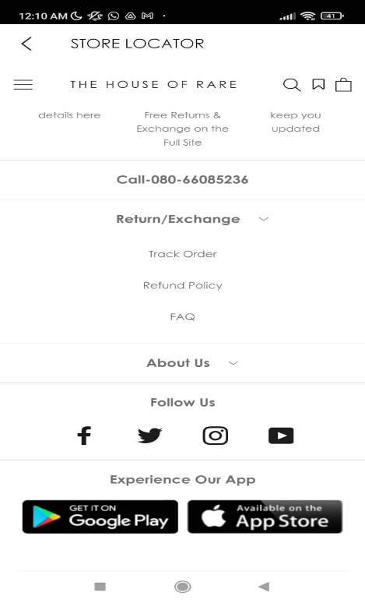

## #8: Aesthetic and minimalist design

### Positive:

* The minimalistic and classy colour combination used in the website draws the attention of users looking for luxury products.

### Negative:

* Unnecessary pictures used in FAQ section are distracting and require to user to scroll too much to get to a particular section.

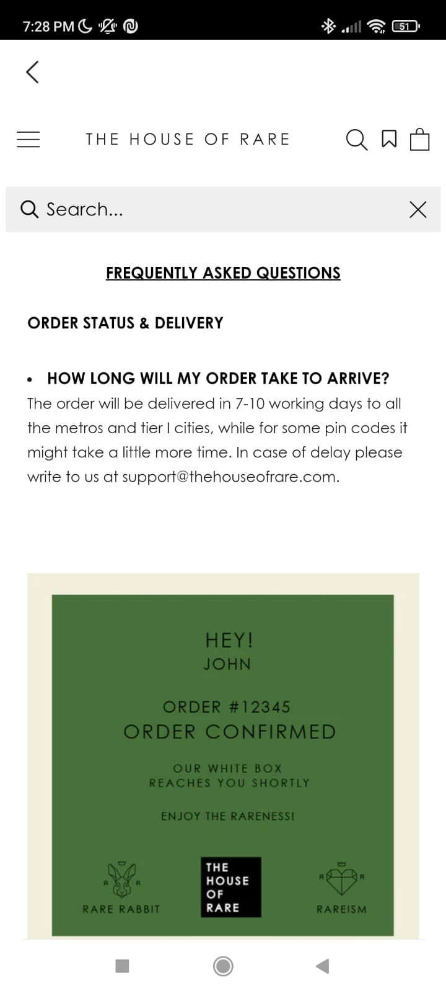

* The remove option from cart is not visible to the user due to overlapping colours which may confuse the users.

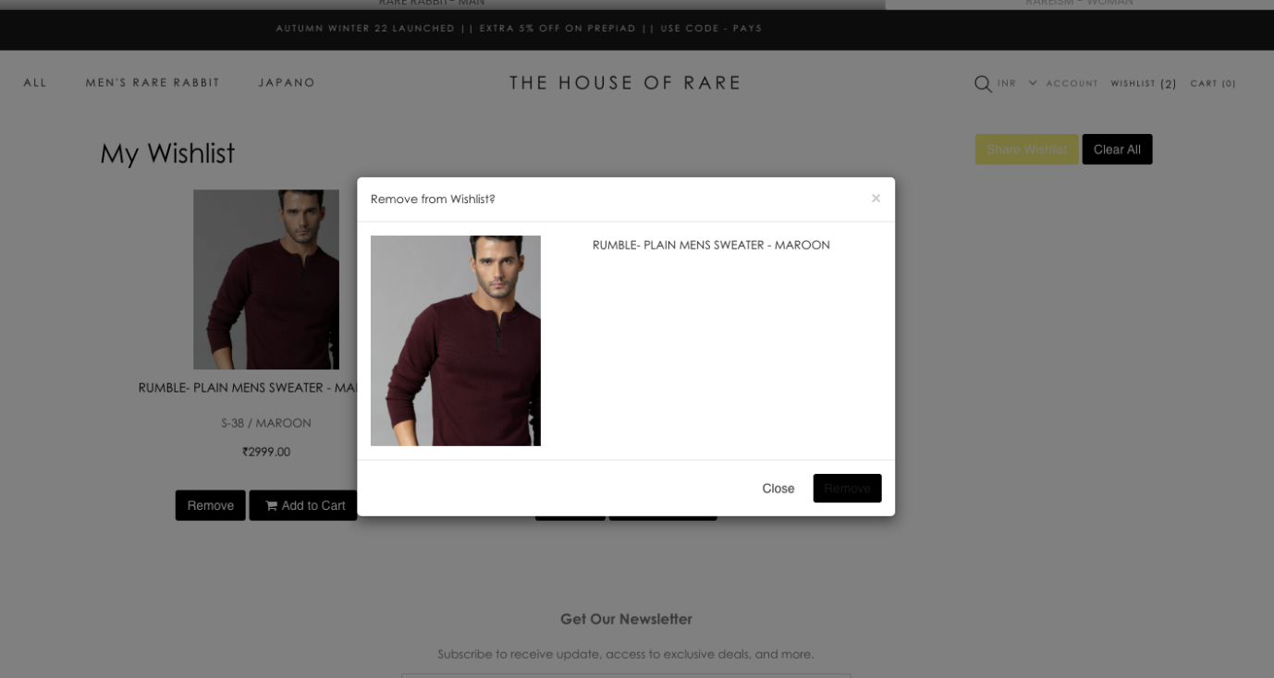

**Recommendation:** The colour combination of the text and button should be contrasting so that it is visible to the users.

References

<https://xyuliu.com/Heuristic-Evaluation>

[https://static1.squarespace.com/static/54d7d226e4b0340f2fb9246e/t/54e015f1e4b033d521c5ac4b/14239 71825318/HeurisitcEvaluation_PaceLibrary.pdf](https://static1.squarespace.com/static/54d7d226e4b0340f2fb9246e/t/54e015f1e4b033d521c5ac4b/1423971825318/HeurisitcEvaluation_PaceLibrary.pdf)

<https://thehouseofrare.com/collections/rare-rr-and-rm>

# Conclusion

The heuristic evaluation is simple to perform and an inexpensive way to assess the impact of the interface and design problems on the overall user experience early in the development process. Conducting the evaluation independently and defining the scope for evaluation by defining the user flows yield better results.

The flaws in design hamper the engagement of the users with the product. The evaluation provides a framework to find opportunities for improvement in the existing product by identifying the existing issues in the product.

The intuitive nature of the evaluation allows both the students and the professionals to give feedback easily. It is an interesting way to put oneself in the shoes of the end users and walk through the product with the interest of the end-users in mind.